Summary
VIBE HOUSE
Stay. Mix. Repeat.

1. Brand Overview
Welcome to Vibe House—your passport to transforming ordinary trips into extraordinary adventures. Whether you're on a city break, business trip, backpacking adventure, family holiday, or school class trip, your stay with us will be incredible!
Our unique mix of hotel comfort and hostel vibes means you get the best of both worlds. What sets us apart? Our unbeatable central locations, budget-friendly rates, Cleanliness, Safety and awesome amenities that make stay fun. Our spaces are all about having fun, meeting new people, and creating fantastic memories.
Vibe House is a social co-living / mixed-gender Global standard hosteller brand designed for modern travellers who seek connection, energy, and safety—not just a bed for the night. Vibe House blends hospitality, community, and curated social experiences under one roof.
Vibe House is built for people who travel solo but never want to feel alone.

2. Brand Philosophy
At its core, Vibe House stands for:
- Interaction – spaces and programming that naturally bring people together
- Mixed-gender co-living – inclusive, respectful, global hostel culture
- Safety & Cleanliness – non-negotiable hygiene and behavioural standards
- High-Energy Social Evenings – evenings designed, not left to chance
The brand removes the anxiety of:
- “What do I do tonight?”
- “How do I meet people?”
- “Is this place safe and clean?”
At Vibe House, the vibe is built-in.

3. Target Audience
Vibe House is designed for:
- Solo travellers (Indian & international)
- Young professionals & digital nomads
- First-time city visitors
- Weekend travellers & party-led explorers
- Long-stay guests who value community
Age group: 18–35
Mindset: Social, open, experience-driven, global

4. The Vibe House Experience
a) Stay
- Mixed-gender dorms with privacy-first design
- Private rooms for guests wanting quieter stays
- Clean, hotel-grade mattresses, linen & washrooms
- Secure lockers and controlled access
b) Social Life (Core Differentiator)
Guests never have to plan their evening.
Every Vibe House property curates:
- Daily evening social hours
- Music-led nights (DJ, playlists, live sets)
- House parties, games, drinking games, open mics
- Community dinners or bar nights
- City-specific experiences (Pub Crawl, Café Crawl, Yoga , Runs)
Social interaction is facilitated but not forced.

5. Safety & House Rules (Brand Backbone)
Vibe House balances freedom with structure.
Safety Measures:
- CCTV in common areas
- Trained staff & night managers
- Secure entry & guest verification
- Zero-tolerance policy on harassment or misconduct
House Rules:
- Clear behaviour and noise policies
- Quiet hours for rest and recovery
- Cleanliness standards enforced daily
- Respect-first, consent-driven environment
This ensures:
- Good sleep
- Hygienic atmosphere
- Comfort for all genders

6. Design & Spaces
Vibe House is designed to make interaction effortless.
Key spaces:
- Central social lounge
- Music-friendly common area
- Bar / café / beverage counter
- Co-working corners
- Outdoor or rooftop hangout zones
Design language:
- Warm lighting
- Bold colours
- Instagram-friendly corners
- Modular furniture for events

7. Cleanliness Standards
Cleanliness is treated like a hotel, not a backpacker dorm.
- Daily housekeeping of dorms & washrooms
- Weekly deep cleaning
- Professional linen management
- Hygiene audits & SOPs
This allows Vibe House to appeal to:
- First-time hostel users
- Female travellers
- International guests

8. Brand Promise
At Vibe House, no one feels like a stranger.
Guests arrive alone.
They sleep well.
They meet people effortlessly.
They leave with stories, friends, and memories.

9. One-Line Brand Definition
Vibe House is a social co-living hosteller where safety, music, and community turn every stay into an experience.

1. COLOR PALETTE (CORE IDENTITY)
Primary Colors
- Charcoal– grounding, nightlife base
- Warm Concrete Grey – urban, neutral
- Electric Yellow – energy & highlights
Secondary Accents
- Deep Teal / Bottle Green (calming balance)
- Off-white / Warm Ivory (cleanliness signal)
Rules
- Dorms = calmer palette
- Common areas = darker + neon accents
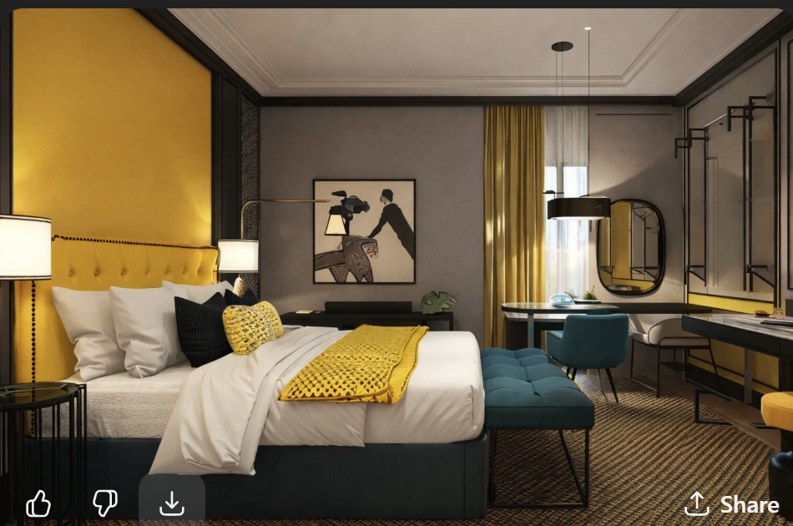

2. LIGHTING PHILOSOPHY
Common Areas
- Warm ambient lighting (2700–3000K)
- Dimmable lights after 7 pm
- Neon signs / LED tubes for accent
- Spotlights on walls, not faces (more flattering)
Dorms
- Individual reading lights per bed
- Motion-sensor night lights (low lux)
- No harsh overhead lighting at night
Corridors
- Linear LED strips
- Wayfinding lighting (soft, directional)

3. SPACE-BY-SPACE DESIGN

Purpose:
Interaction, music, games, pre-party energy
Design Elements
- Long communal tables (wood + metal)
- Mixed seating: sofas, bar stools, poufs
- DJ console / music corner (even if playlist-driven)
- Wall art + neon quote:
  - “Stay. Mix. Repeat.”
  - “Come alone. Leave with friends.”

B. MUSIC-FRIENDLY COMMON AREA

- Built-in speaker niches
- Acoustic panels disguised as art
- Minimal stage / raised platform
- Lockable DJ console storage
Important:
Design for sound containment so dorms stay quiet.

C. DORMS (SLEEP IS SACRED)
Design Rules
- Pod-style or semi-enclosed bunks
- Curtains or privacy panels mandatory
- Personal shelf + charging per bed
- Matte finishes, no glossy surfaces
Color Tone
Psychology:
Guests party harder when they know sleep will be good.

D. WASHROOMS (TRUST BUILDER)

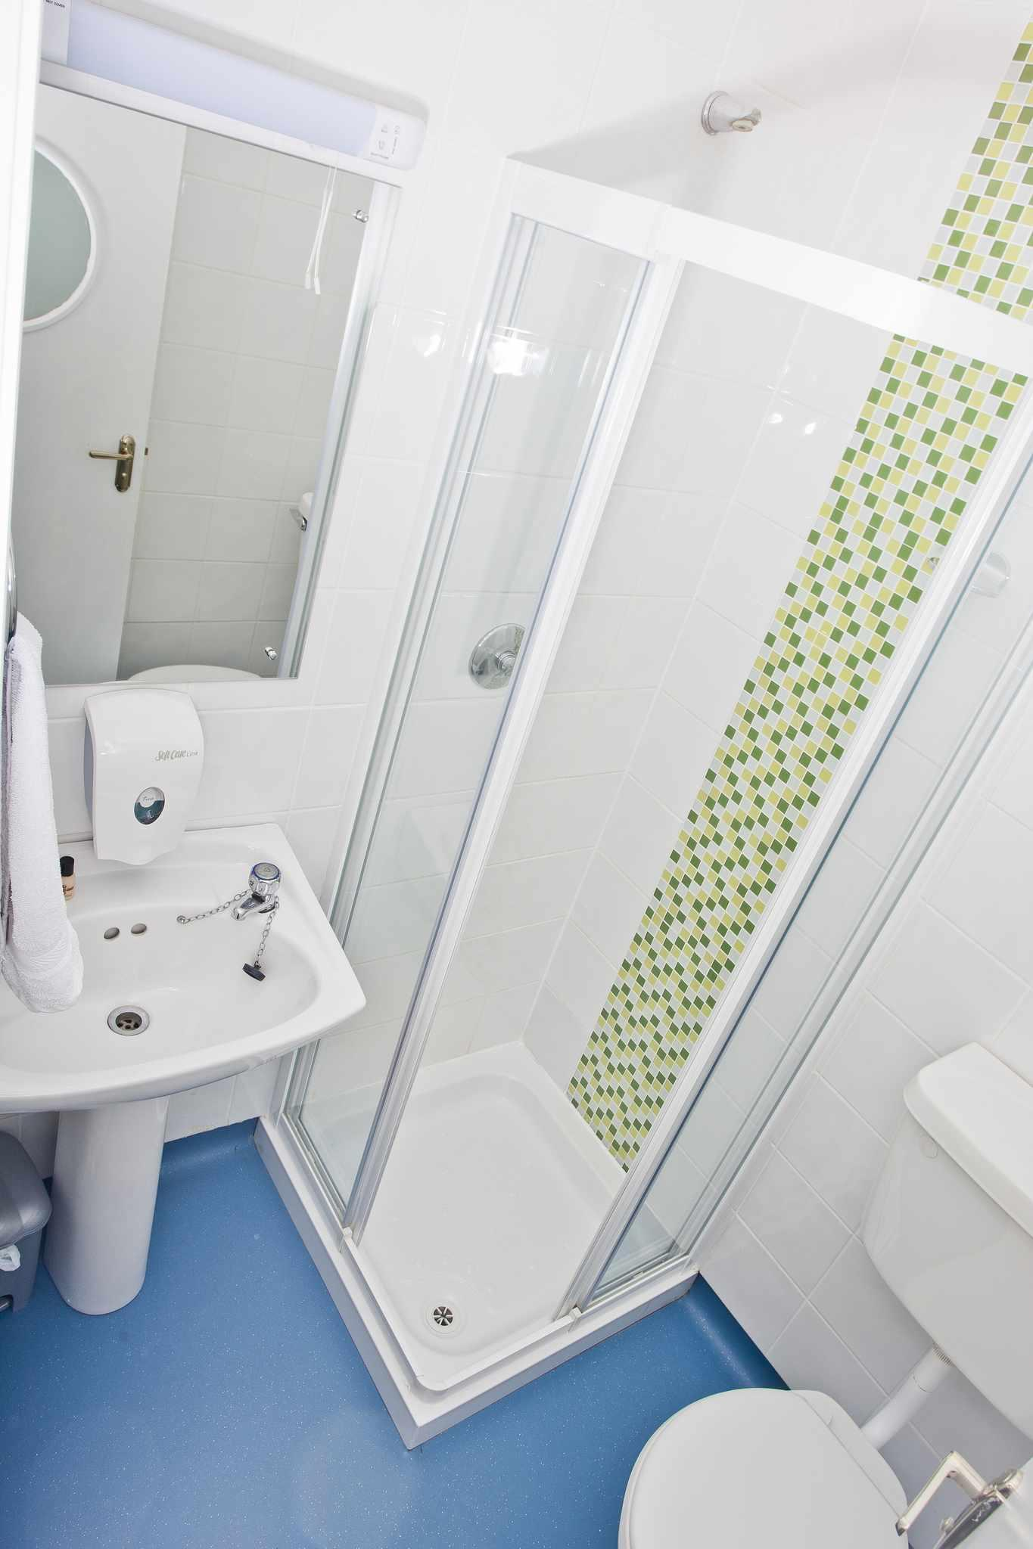

- Hotel-style mirrors
- Individual cubicles
- Bright but warm lighting
- Clear signage & rules
Materials
- Anti-slip tiles
- Matte black fittings
- Easy-to-clean surfaces only

CO-WORKING / CHILL CORNERS

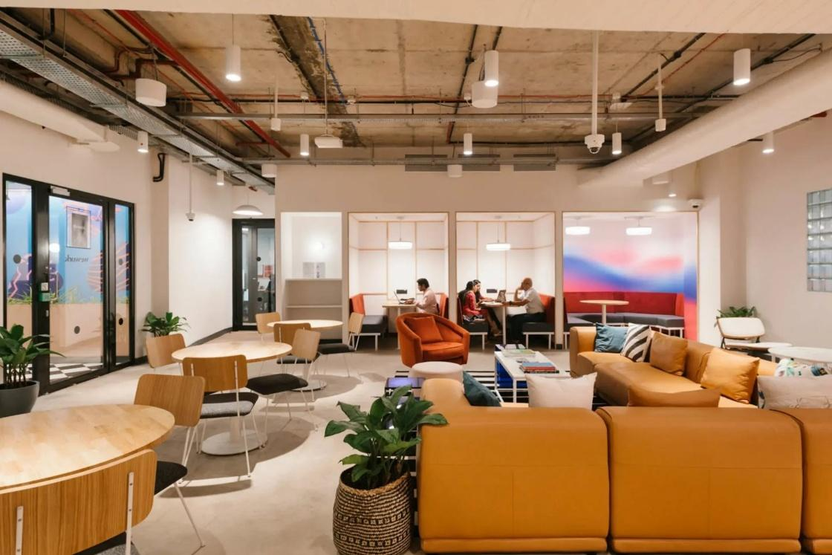

- Quieter zone
- Softer lighting
- Plants + wood finishes
- USB + power everywhere

F. ROOFTOP / OUTDOOR ZONE (IF AVAILABLE)
- String lights
- Moveable seating
- No permanent bar fixtures
- Flexible for events / yoga / chill

4. GRAPHICS, SIGNAGE & BRAND VOICE
Typography
- Bold sans-serif (Montserrat / Inter / Poppins)
- Large wall typography
- Minimal text, strong statements
Signage Tone
- Friendly, witty, clear
Examples:
- “Respect the vibe.”
- “Party smart. Sleep easy.”
- “This is a shared space. Act like it.”

5. CLEANLINESS-BY-DESIGN
Design choices that force hygiene:
- Wall-mounted fixtures
- Closed storage
- Dark grout (hides stains)
- No fabric in wash areas
- Easy mop zones
Clean should feel intentional, not enforced.

Tech BRD
Project: Guest Experience & Operations Automation Platform
Property: 40-Key Hybrid Hostel – Koramangala

1. Guest Interface (Web-Based, Mobile-First)
Objective
Create a no-download, mobile-first web application (PWA) that becomes the central control panel for guests from booking to post-stay. The goal is to reduce front desk dependency, increase add-on revenue, and automate payments.
Access Points
- Booking confirmation link (direct & OTA redirect)
- WhatsApp automated link
- QR code placed in rooms and dorms
Functional Scope
A. Pre-Arrival (During Booking – Upsell Engine)
Guests are presented with an “Enhance Your Stay” section during booking and post-booking.
Add-ons include:
- Water Bottle – 100
- Bath Towel - 200
- Safe Lock – 150
- Toilet Kit – 150
- Laundry - 150
- Early Check-in - 250
- Late Checkout (discounted if pre-booked) - 250
System Requirement:
- Pre-booked late checkout priced lower than same-day request.
- Instant online payment mandatory.
- Auto-post to PMS folio.
Objective:
Increase ancillary revenue before arrival and reduce on-property negotiation.

B. Post-Booking (Before Arrival – Web Check-In)
Guests receive automated WhatsApp link to:
- Upload ID (KYC integration)
- Complete registration details
- Pay pending balance ( Only if not paid earlier )
- Pre-select add-ons
- Pre-book late checkout
- View property guide
- View room details, room number, bed number , with lock passcode and locker if bought.
Outcome:
Front desk workload reduced to verification and hospitality instead of paperwork.

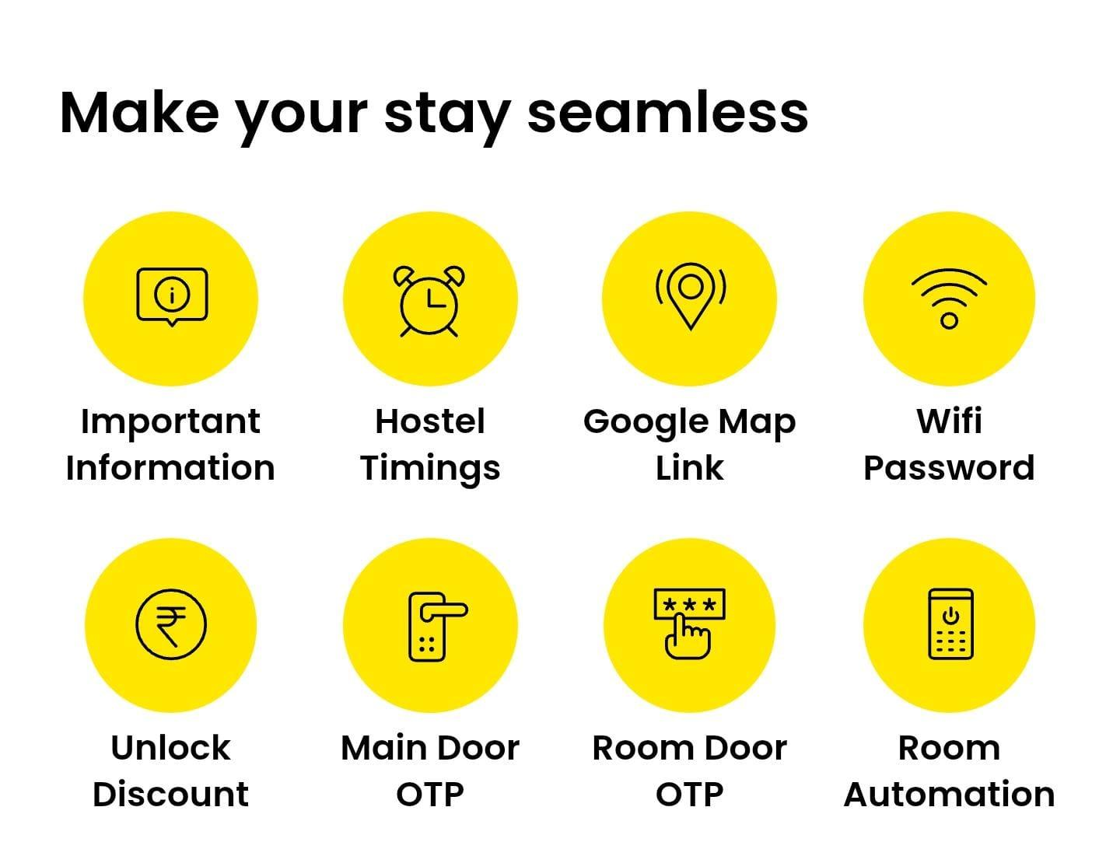
C. During Stay (Make your stay comfortable)
Guest dashboard will allow:
Room Request (Services):
- Towel – Chargeable
- Blanket – Chargeable
- Toiletries - Chargeable
- Locker – Chargeable
- Laundry pickup – Chargeable
- Room cleaning – Free
- Washroom Cleaning – Free
- Garbage clearance – Free
- Linen change – Free
Maintenance:
- Wifi issues
- Hot water issues
- Air conditioning issues
- Other issues ( request for any other maintenance services )
- First Aid
- Staff assistance
- Lost & found
- Iron ( Subject to availability )
- Hair dryer ( subject to availability)
- Umbrella ( Subject to availability)
- Luggage storage – 3rd party paid service ( tuckit )
Time & Room Control:
- Extend stay
- Late checkout
- Upgrade dorm to private
- Lower bunk upgrade
System must:
- Check live availability via PMS API
- Show dynamic pricing
- Process instant payment
- Auto-confirm booking
- Trigger department task
No manual intervention required.

Payment System Requirements
All transactions must:
- Support UPI, card, wallet
- Be prepaid (no pay-later for small items)
- Auto-generate invoice line item
- Auto-post to PMS folio
- Trigger operational task only after successful payment
Example Flow:
Guest purchases Bath Towel ₹129 →
- Payment success confirmation
- Housekeeping task created
- Auto-assigned to available staff
- 15-minute SLA timer initiated
- Guest notified upon completion
This ensures revenue integrity and service accountability.

2. Staff Task Dashboard
Objective
Digitize and automate all service requests to reduce coordination overhead and improve response times.
Functional Requirements
- Real-time task queue by department
- Auto room mapping from booking data
- Priority tagging (high/medium/low)
- SLA timer per task category
- Task completion confirmation
- Escalation logic if SLA breached
Staff View:
- Assigned tasks
- Remaining SLA time
- Room number
- Completion button
Supervisor View:
- Pending tasks
- SLA performance metrics
- Staff productivity tracking
- Department bottlenecks
Outcome:
Eliminates verbal coordination and reduces dependency on front desk.

3. Auto Assignment + SLA Tracking Engine
Objective
Ensure automated task routing and service performance monitoring.
Functional Logic
- Requests auto-tagged by category (Housekeeping / Maintenance / Front Office)
- Auto-assignment based on:
  - Staff availability
  - Current task load
  - Shift timing
- SLA rules:
  - Towels: 15 minutes
  - Maintenance: 30 minutes
  - Laundry pickup: 20 minutes
Escalation Flow:
If SLA breached →
- Notify supervisor
- Flag in dashboard
- Record in performance log
Outcome:
Professional service consistency with lean staffing.

4. Data & Analytics Layer
Objective
Provide actionable operational and revenue intelligence.
Revenue Analytics
- Daily add-on revenue
- Item-wise sales performance
- Conversion rate of upsells
- Late checkout revenue contribution
- Upgrade revenue tracking
Operational Analytics
- Average response time per department
- SLA compliance %
- Peak request timing analysis
- Dorm vs Private service patterns
- Staff performance scoring
Inventory Control Module
Track for:
- Locks
- Towels
- Toiletry kits
- Extra mattresses
Metrics:
- Opening stock
- Sold
- Damaged
- Remaining
- Auto low-stock alerts
Purpose:
Prevent internal leakage and shrinkage.

5. Upsell & Revenue Optimization Engine
Objective
Maximize per-guest revenue through automation and dynamic pricing.
Features
Dynamic Late Checkout Pricing
- If next day occupancy > 80% → increase price
- Weekend premium pricing
- Same-day late checkout priced higher than pre-booked
Automated Extension Engine
When guest selects extension:
- Check live PMS inventory
- Apply dynamic rate
- Confirm instantly post-payment
- Update folio automatically
Dorm Upsell Logic during booking
If dorm occupancy < threshold:
- Offer lower bunk upgrade ₹149
- Offer private room upgrade at dynamic discount
Scarcity Triggers
Automated notifications:
“Limited late checkout slots remaining”
“Upgrade available at special price”
Outcome:
3–5% incremental revenue on total property revenue through automation.

Reference images - 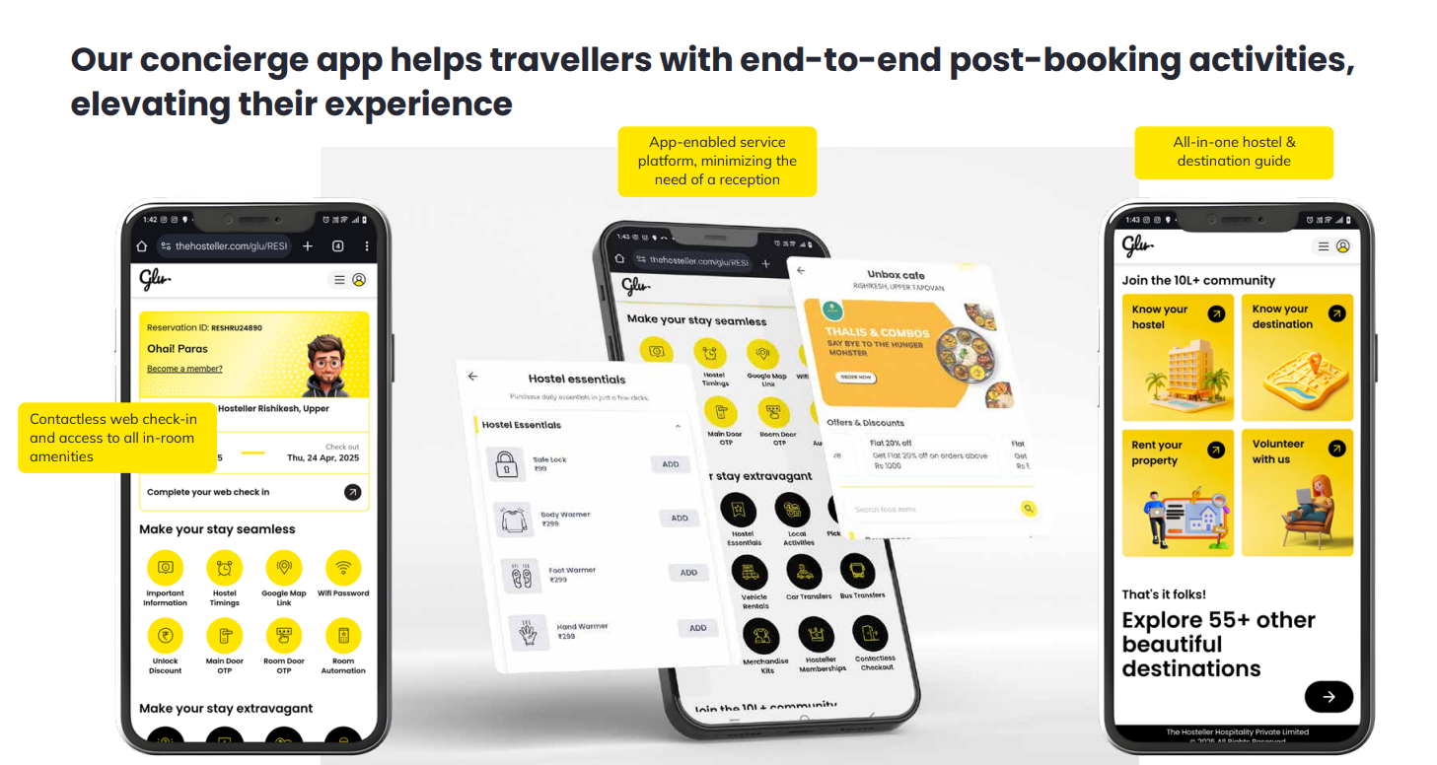
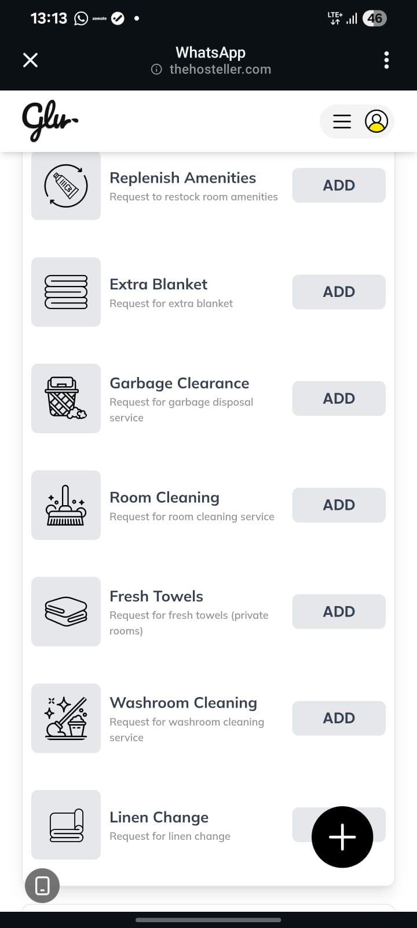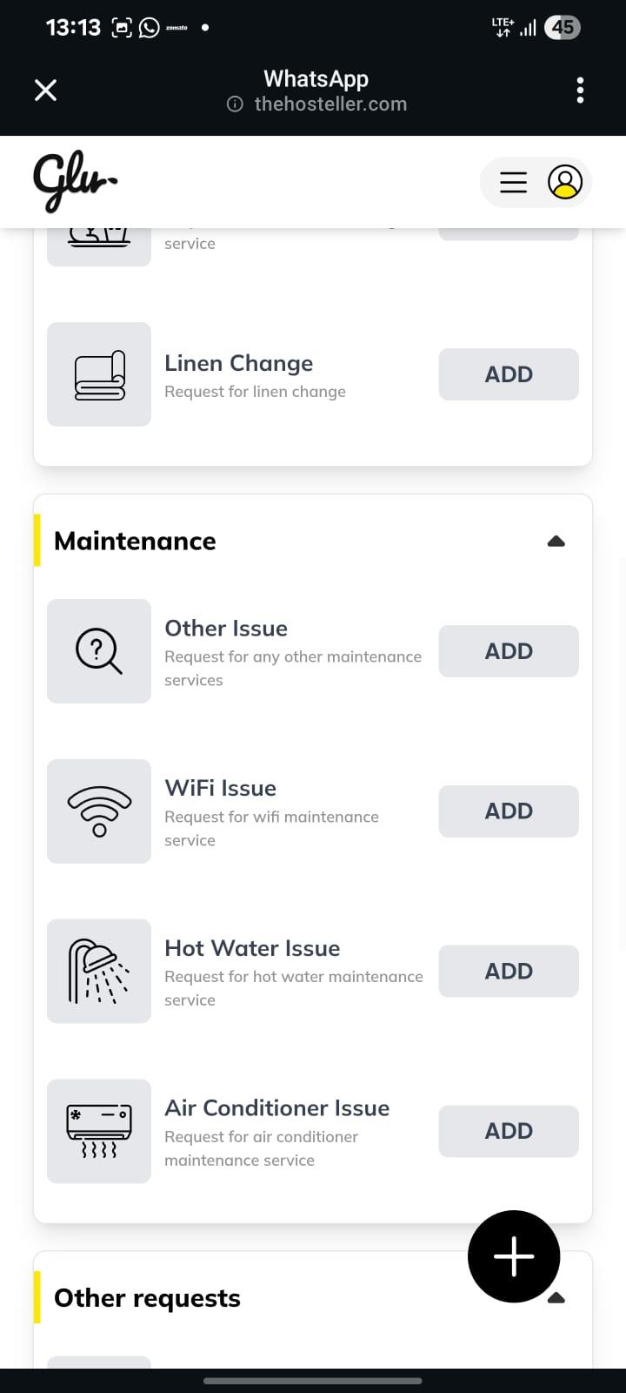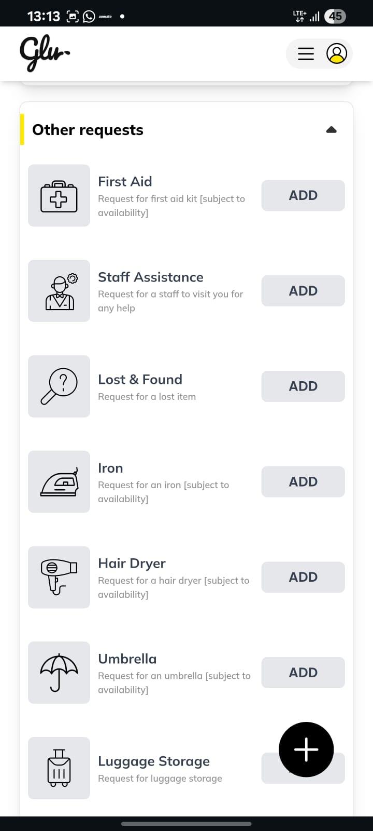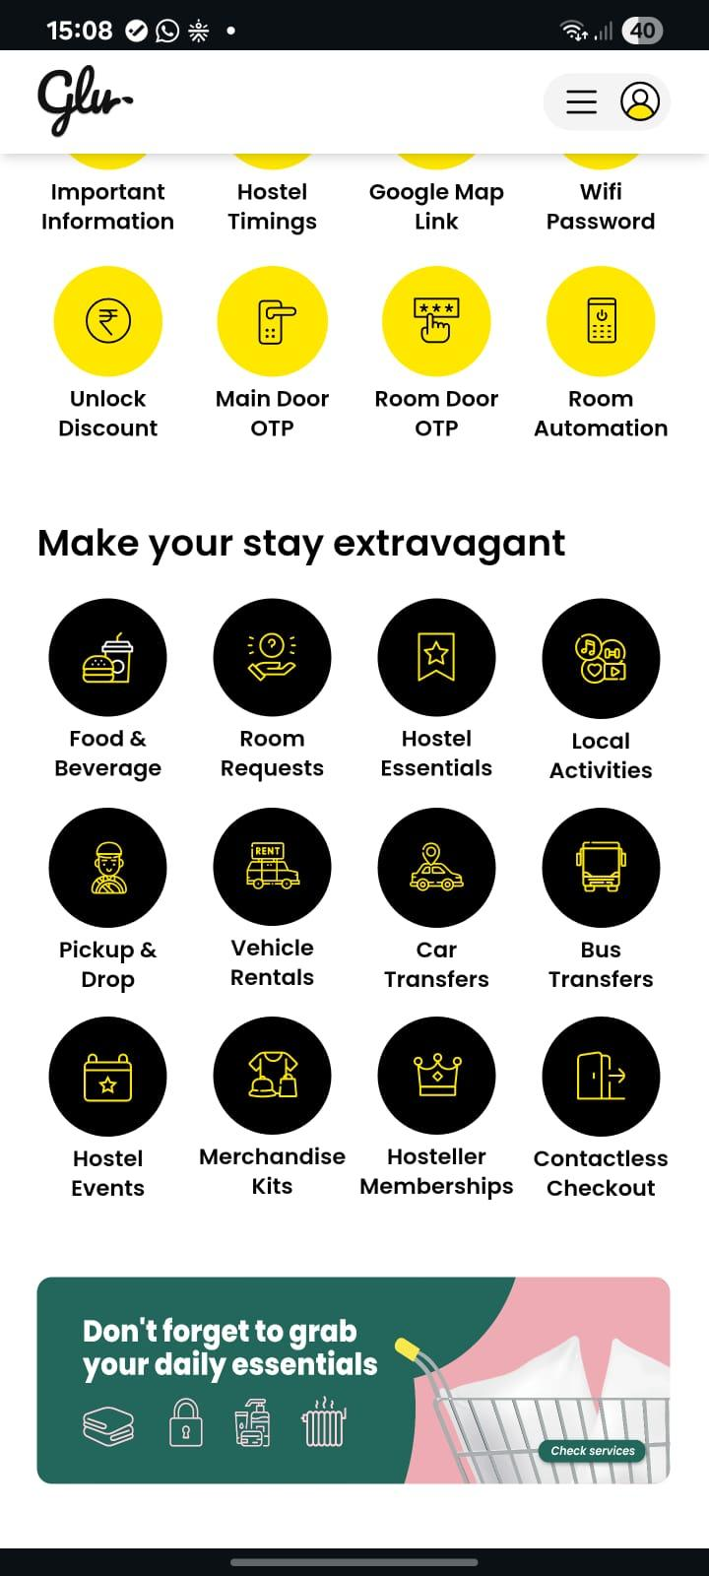

Appendix
Images similar to our interiors
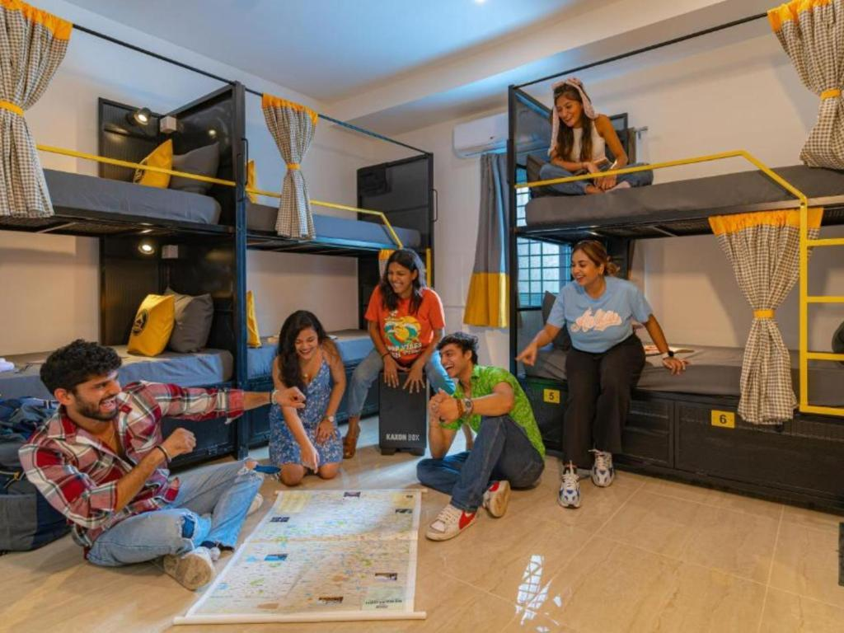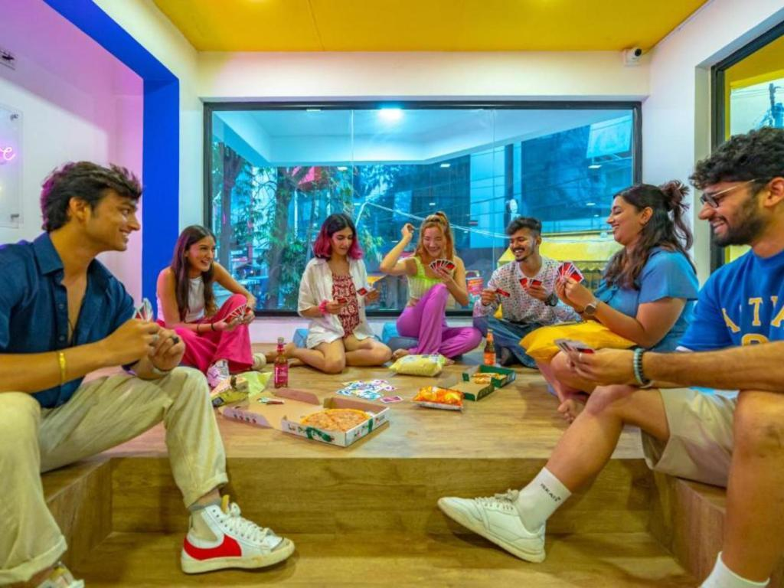
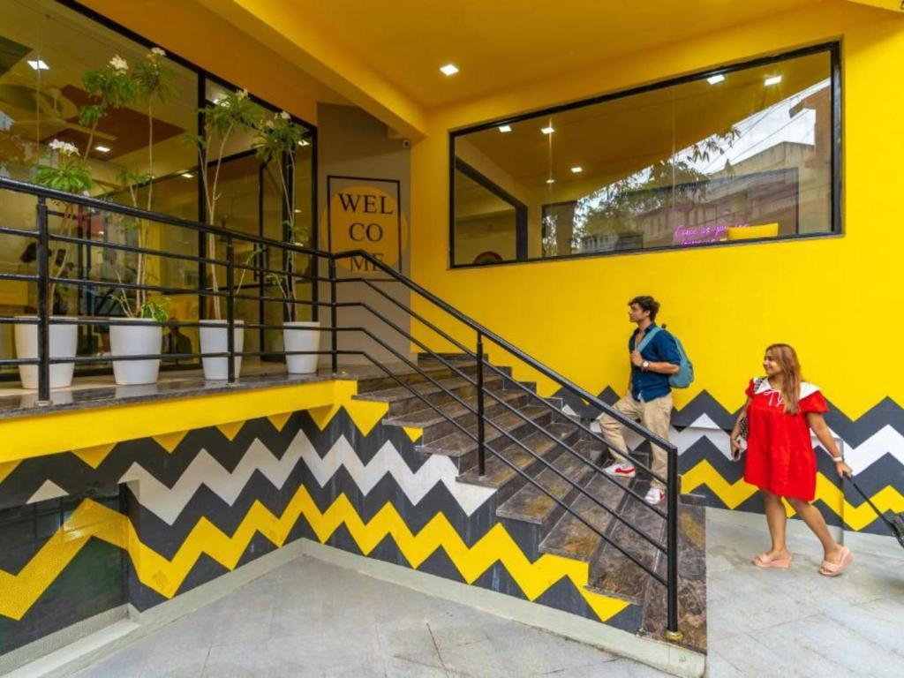


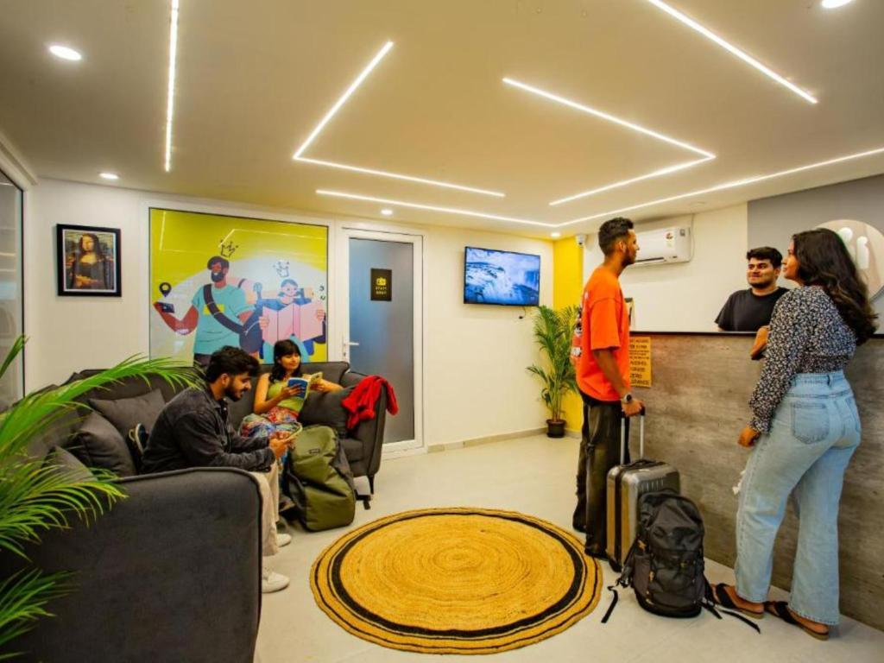
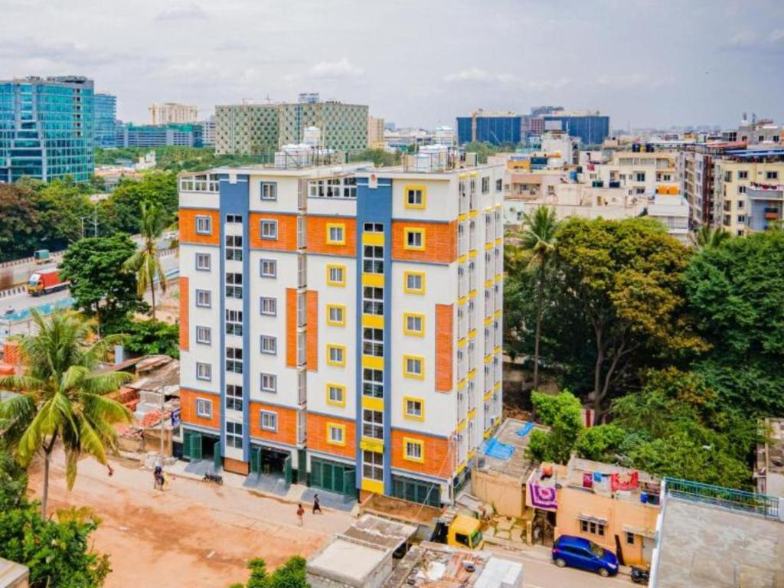

Questions from meeting 9 Feb
Questions from meeting 9 Feb

- Will one time OTP valid in the duration of the stay to access rooms and lockers safe
What if :-
  - Say the cx invites his friends to crash into his room, giving them the OTP as well.
  - OTP is compromised via some means and now anyone can barge into a customer's room or steal their luggage.

- Edge cases handling, are fully automated doors safe
What if:-
  - Emergency like a fire broke out? Will cx feel safe staying inside?
  - Someone forgets his phone, phone got switched off, internet not working, he will be denied access.
  - (not applicable if the WC is in the dorm room), someone needs to take a bath or needs to use the WC. We can’t expect them to carry their phones around.
  - Say for example housekeeper have their handfull, and are not able to use their phone in the meantime

The "Single Point of Failure" Risks
  - Network Outage Recovery: If the property Wi-Fi fails, how do the "Main Door OTP" and "Room Door OTP" communicate with the central server? Is there a Bluetooth or NFC fallback for the PWA to unlock doors locally?
  - Hardware Power Failure: In the event of a power cut, do the automated locks default to "Fail-Safe" (unlocked for safety) or "Fail-Secure" (locked for security)? If they are "Fail-Secure," how will guests access the "Mixed-gender dorms" without manual keys?
  - PWA Session Timeout: If a guest is logged out of the web-app due to inactivity or a cleared browser cache while they are in the shower or common area, what is the "Zero-Phone" verification process for staff to re-authenticate them?
  - What if our servers crash :- Doesn’t necessarily have to be a prod crash, we had instances where AWS has crashed which is beyond our control.

Cloud to cloud.
Guest Logins?
race conditions.

Booking from 3P, then onboarding on ours
If occupancy is full, then will ezee increase the price?

what ezee supports vs what we need

data handling

scarcity triggers:
more specifications on the slot structure.
how to decide which user gets the upgrade

References

https://wakumari.notion.site/FLOWER-TERRACE-HIGASHI-SHINJUKU-3703568d0575438d9cfa2081ab5c6660

Our pleasure!
--------------
■■CHECK-IN CODE■■
18124117
■■■■■■■■■■■■■

■Check-in QR/ Pre check-in■
https://www.onestayapp.com/v2/checkin/search?checkin_code=18124117&pin_code=62qszvz6ma&referral=email
■■■■■■■■■■■■■
Before check-in, please enter your info in the Pre check-in in the URL.
The check-in will be smooth and you’ll enter the room early.

【IMPORTANT!!!!!!】
■■1st floor door PIN ■■
①Press ”呼出call “ ONCE
②Press 0817
→OPEN
■■■■■■■■■■■■■

--------------
Check in
June 09, 2025 /04:00 PM
Check out
June 14, 2025 /11:00 AM
--------------

【SELF CHECK IN&OUT】
Please check in & out with a tablet on 1st floor by yourself.
The room key is "4-digit number". The number will be displayed on the tablet after the check-in procedure.

■■HOTEL GUIDE■■
All information is in here.For any questions, please check here first.
https://wakumari.notion.site/FLOWER-TERRACE-HIGASHI-SHINJUKU-3703568d0575438d9cfa2081ab5c6660
■■■■■■■■■■■
↑ If the URL is not working, please check from "pre-checkin URL"→"HOTEL GUIDE"

￣￣￣￣￣￣￣￣￣￣￣￣￣￣￣
【Bed】
You can convert the sofa bed into a bed very easily.
https://wakumari.notion.site/Extra-bed-pillows-blankets-e98ff9832fe04ac6a0eaefbb27f52e75?pvs=4

￣￣￣￣￣￣￣￣￣￣￣￣￣￣￣
【Recommended restaurants】
https://wakumari.notion.site/Recommended-restaurants-1723a77e637c80309456c54471b0b721?pvs=4

￣￣￣￣￣￣￣￣￣￣￣￣￣￣￣
This is an apartment-type hotel with no front desk and self-check-in.

We will support you 24 hours a day. If needed, we will go to your room to help.
Please feel free to ask me if you have any other questions.

Have a great trip!

FLOWER TERRACE HIGASHI SHINJUKU team

T2B questions
Questions to be asked for Tech Understanding

Q1. What happens when the on-site technology fails, such as the door lock battery dying or the Wi-Fi connection for the door going down?

Q2. What if the server goes down? Is there a backup or fallback plan for how guests can enter their rooms or access their lockers?
Context: There may be times when the server goes down despite our best efforts to prevent it, or when cloud services like AWS experience outages.

Q3. If a user signs up through a 3rd party website like MMT or Booking.com, how are we supposed to inform them to use our web-app to complete their verification and receive their room passkey?

Q4. Regarding KYC verification, how are we supposed to conduct it? Will we have a face recognition device to verify guests, or do we need more specific details on the process?

Q5. Do we prefer an SMS-based OTP or an email-based OTP for login (to enable 2FA)? Also, what options are we providing to the guest during sign-up (e.g., Google-based, email-based, etc.)?

Q6. The document mentions "If dorm occupancy < threshold," "If next day occupancy > 80%," and "Weekend premium pricing." How will we decide these prices, and does the PMS provide support for these types of features?

Q7. scarcity triggers:
- More specifications on the slot structure.
- How to decide which user gets the upgrade?

___________________________________________________________________

Q8. Validate early late CheckIn- CheckOut.
Q9. Which KYC docs.
Q10. Should we use Booking IDs.
Q11. Can you allow partial checkin.
Q12. Type of lockers and lock details needed.

DB proposal
DB Proposal

The blunt conclusion first
👉 Your core system MUST be SQL-first
👉 You should add NoSQL only as a supporting layer (not the backbone)
If you tried to build Vibe House purely on NoSQL, you’d hit revenue leaks, inventory mismatch, and operational chaos within weeks.
Let me explain why, mapped exactly to your real flows.

Why SQL is non-negotiable for Vibe House
Your business is hospitality + money + inventory + SLAs.
That combination screams relational integrity.
Below are the exact parts of your system that force SQL.

1. Payments + Folio posting = ACID or disaster
From your doc:
“Auto-post to PMS folio”
“Trigger operational task only after successful payment”
“No manual intervention required”
This means:
- Payment succeeds
- Invoice line item created
- PMS folio updated
- Task created
- SLA timer started
❗ These steps must succeed together or fail together.
That’s textbook SQL transaction territory.
What SQL gives you
- Transactions (BEGIN → COMMIT / ROLLBACK)
- No orphan payments
- No unpaid tasks
- No “paid but not delivered” horror stories
If you used NoSQL here
- Eventual consistency = race conditions
- Duplicate towel deliveries
- Missing revenue entries
- Nightmares during audits
👉 Payments, folios, invoices, add-ons → SQL only

2. Live availability & upgrades are relational by nature
From your flows:
- Extend stay
- Upgrade dorm → private
- Lower bunk upgrade
- Dynamic pricing based on occupancy
- PMS API availability checks
This means your data looks like:
- Property
- Room
- Bed
- Booking
- Guest
- Date ranges
- Occupancy thresholds
These relationships are deeply interconnected.
SQL excels because
- You can lock rows during availability checks
- Prevent double booking
- Guarantee bed-level accuracy
- Calculate occupancy in real time with joins
NoSQL can do this — but with custom logic that’s fragile and expensive.
👉 Inventory, bookings, beds, upgrades → SQL

3. Inventory control & shrinkage prevention
You explicitly mention:
“Prevent internal leakage and shrinkage”
That’s a huge tell.
Inventory needs:
- Opening stock
- Sold
- Damaged
- Remaining
- Auto low-stock alerts
This is classic ledger-style data.
SQL advantages
- Constraints (stock can’t go negative)
- Auditable history
- Clean reconciliation
NoSQL would make audits painful.
👉 Locks, towels, kits, mattresses → SQL

4. SLA tracking & staff accountability
Your ops engine includes:
- SLA timers
- Escalations
- Staff productivity
- Performance logs
That’s structured, historical, query-heavy data.
You’ll ask questions like:
- Average SLA by department last 30 days
- Who breached most SLAs?
- Peak failure windows
SQL wins hard here
- Aggregations
- Time-series analysis
- Reporting
👉 Tasks, SLAs, staff performance → SQL

Where NoSQL DOES make sense for you
Now the important nuance: you should not be SQL-only.
There are parts of Vibe House that benefit massively from NoSQL.

1. Guest interaction & flexible content
Examples from your system:
- Property guides
- House rules
- Event schedules
- City experiences
- WhatsApp / PWA payloads
These change often and vary by property.
NoSQL fits because
- Schema evolves fast
- Different properties ≠ identical structure
- Easy to version content
👉 Guest-facing content → NoSQL (Document DB)

2. Event & activity logs (non-financial)
You’ll generate tons of:
- Button clicks
- Page views
- Funnel analytics
- Upsell impressions
- Conversion tracking
You don’t need strict consistency here — you need volume.
👉 Analytics events → NoSQL

3. AI / future personalization layer
You will eventually do:
- Personalized upsells
- Stay behavior analysis
- Dynamic nudges (“Guests like you booked X”)
Those models consume semi-structured data.
👉 Behavioral data, AI features → NoSQL

The architecture I’d recommend (clean & scalable)

Core System (Authoritative Source of Truth)
SQL (PostgreSQL)
- Guests
- Bookings
- Rooms / beds
- Payments
- Add-ons
- Inventory
- Tasks
- SLAs
- Staff

Flexible + High-Volume Layer
NoSQL (MongoDB / DynamoDB)
- Property content
- Guest guides
- Events
- Interaction logs
- AI signals

Performance Layer
Redis
- Session state
- Availability caching
- SLA countdowns
- Rate limiting
This setup matches exactly how serious hospitality tech stacks work.

REAL LIFE EXAMPLES OF HOW SQL WORKS OVER NO-SQL

1️⃣ Payments & Transactions

Scenario
User asks:
“I bought a towel, why hasn’t it arrived?”

What actually happened in the system
- Guest clicks Buy Towel
- Payment gateway confirms ₹129
- Invoice line item created
- Task sent to housekeeping
- SLA timer starts

Why SQL wins
In SQL, this is ONE transaction:
BEGIN;
INSERT INTO payments (...);
INSERT INTO invoices (...);
INSERT INTO tasks (...);
UPDATE inventory SET stock = stock - 1;
COMMIT;

If any step fails → ROLLBACK
Result:
- No money stuck
- No fake task
- No inventory mismatch

What goes wrong in NoSQL
- Payment doc created
- Task creation fails
- Inventory not updated
- Guest paid, staff never notified
Now support is manually fixing things.
👉 Money + promises = SQL every time

2️⃣ Live Availability & Upgrades

Scenario
User asks:
“Why did my dorm extension fail even though beds were showing available?”

Real flow
- Two guests try to extend stay at the same time
- Only 1 bed left
- Both click “Extend”

Why SQL wins
SQL can lock the bed row:
SELECT * FROM beds
WHERE bed_id = 42
FOR UPDATE;

Only one transaction proceeds.
The other gets rejected cleanly.

NoSQL problem
- Both read “bed available”
- Both write booking
- Now you have double-booked beds
- Front desk panic at 11 PM 😬
👉 Anything involving limited inventory → SQL

3️⃣ Inventory Control (Shrinkage Prevention)

Scenario
User asks:
“Why are we out of towels when system says 10 left?”

Required reality
- Opening stock: 50
- Sold: 30
- Damaged: 5
- Remaining: 15

Why SQL wins
You enforce constraints:
CHECK (stock >= 0)

You also maintain an audit trail:
- Who sold
- When
- Which room

NoSQL problem
- Stock is just a number in a document
- Two writes race
- One overwrites the other
- Inventory silently wrong
Now shrinkage looks like theft.
👉 Anything countable & auditable → SQL

4️⃣ SLA Tracking & Escalations

Scenario
User asks:
“Why was my towel late and no one responded?”

System expectation
- Towel SLA = 15 min
- Auto escalation after breach
- Supervisor notified

Why SQL wins
SQL easily answers:
SELECT AVG(completion_time)
FROM tasks
WHERE department = 'Housekeeping'
AND date > now() - interval '7 days';

You get:
- SLA compliance %
- Staff performance
- Bottleneck analysis

NoSQL problem
- Data exists but fragmented
- Hard to aggregate reliably
- Analytics becomes slow & expensive
👉 Operational metrics → SQL

5️⃣ Multi-Step Guest Actions (Atomic Flows)

Scenario
User asks:
“I upgraded to a private room but money got deducted and room didn’t change.”

Required atomic flow
- Payment success
- Old bed released
- Private room booked
- PMS updated
- New invoice generated

Why SQL wins
All steps succeed or none do.
If room booking fails → payment rolls back.

NoSQL problem
- Each step is an event
- One consumer fails
- You reconcile later (if you notice)
Guests don’t care about “eventual consistency”.
👉 Guest trust flows → SQL

6️⃣ Compliance, Audits & Disputes

Scenario
User asks:
“GST invoice for last month, item-wise breakdown.”

Why SQL wins
- Clean joins
- Deterministic numbers
- Reproducible reports
Auditors love SQL-backed systems.

NoSQL problem
- Data duplicated
- Versions mismatch
- Reports don’t match yesterday’s numbers
👉 Finance + compliance → SQL

7️⃣ Reporting & Business Decisions

Scenario
Founder asks:
“Which upsell makes the most money on weekends for dorm guests?”

SQL answer
One query. Done.

NoSQL answer
- ETL pipeline
- MapReduce / aggregation jobs
- Higher cost
- Slower insight
👉 Decision-making data → SQL

Technical Proposal: eZee PMS Integration

Technical Proposal: eZee PMS Integration & Feasibility Analysis
Date: February 11, 2026

1. Summary
This document provides a detailed feasibility analysis of integrating the Vibe House Guest Interface (PWA) with eZee Technosys APIs. The goal is to automate guest services, inventory tracking, and revenue optimization as outlined in the Vibe House Concept Note. The analysis highlights where eZee's native capabilities align with our needs and where custom development is required to bridge gaps.

2. Capability Analysis

A. Retail Inventory Management (Physical Goods)
The Requirement: Vibe House plans to sell physical items like water bottles, toilet kits, and locks directly through the PWA. It is critical that the system tracks the exact quantity on hand to prevent users from purchasing items that are out of stock.
- eZee PMS Capability: The eZee PMS API is primarily designed for financial tracking. It allows us to post an "Extra Charge" to a guest's folio using the AddExtraCharge endpoint. This ensures that the revenue is recorded correctly in the daily sales report and the guest's final bill.
- Limitation: The core PMS API does not track physical stock counts (e.g., it cannot tell you that there are only "5 water bottles left"). While eZee has a POS module (Optimus) that handles this, integrating a full POS solely for a few hostel amenities adds significant complexity and cost. Relying strictly on the PMS would require manual stock checks, leading to potential discrepancies.
- Recommendation: Implement a "Decoupled Inventory" system. The Vibe House PWA database should act as the master record for physical stock counts, while the eZee API is used solely to record the financial transaction after a successful sale.

B. Dynamic Pricing (Occupancy-Based Rates)
The Requirement: To maximize revenue, the system needs to automatically increase room rates when the property occupancy exceeds a certain threshold (e.g., >80% occupancy). This logic needs to happen in real-time during the booking process.
- eZee PMS Capability: eZee supports rate overrides via its Reservation API. When creating a booking programmatically, the API allows us to submit a specific rate that differs from the standard base rate managed in the PMS. Additionally, the Retrieve Room Information API provides the raw data needed to calculate current occupancy levels.
- Limitation: The PMS does not natively perform the calculation for dynamic pricing unless the paid "eZee Mint" revenue management module is active. Without this module, the PMS is passive—it will accept whatever price is sent to it, but it will not automatically suggest a surge price based on demand.
- Recommendation: Build a lightweight "Pricing Engine" within the PWA backend. This engine will query the live occupancy from eZee, apply our custom logic (e.g., +20% price), and then send the final calculated rate to eZee during the booking confirmation step.

C. Granular Bed Selection (Upper vs. Lower Bunks)
The Requirement: Guests should be able to pay a premium to select a specific bed preference, such as a "Lower Bunk." This requires the system to distinguish between different beds within the same dorm room and manage their availability separately.
- eZee PMS Capability: eZee PMS structures inventory by "Room Type." For a dorm, it sees a single room with multiple "slots" (e.g., a 6-bed dorm has a capacity of 6). It does not natively distinguish between "Bed 1 (Lower)" and "Bed 2 (Upper)" in terms of inventory availability. It treats all slots as identical.
- Limitation: Because the PMS cannot distinguish between bed types, it cannot prevent a scenario where two guests book the last "Lower Bunk" simultaneously if we rely only on eZee. The system effectively treats the room as a "bucket" of beds rather than individual units.
- Recommendation: Maintain a "Shadow Inventory" in the Vibe House database that maps specific bed numbers (e.g., 101-L, 101-U) to the generic eZee room slots. The PWA will handle the availability check for the specific bed, charge the premium fee via API, and append the bed preference to the booking "Remarks" field for the front desk staff.

D. Service Add-ons (Late Checkout, Laundry)
The Requirement: The system must allow guests to purchase services like "Late Checkout" or "Laundry" via the app. For operational efficiency, these requests need to be limited (e.g., only 5 late checkouts allowed per day) and immediately billed.
- eZee PMS Capability: The AddExtraCharge endpoint is highly effective here. It allows us to post charges directly to a reservation ID or Room Number. This integrates seamlessly with the guest's final invoice.
- Limitation: Similar to physical inventory, the PMS API does not natively enforce "service caps" (e.g., "max 5 late checkouts"). If 10 guests request it via the API, the PMS will likely accept all 10 charges unless external logic prevents it.
- Recommendation: Use the PWA to enforce the operational limits (the "cap"). Once the PWA verifies that a slot is available, it pushes the charge to eZee to finalize the transaction.

3. Relevant API Reference
The following APIs from the eZee Connectivity Portal will be utilized for this project:
- Retrieve Room Information (Occupancy Check)
  - Endpoint: https://live.ipms247.com/pmsinterface/pms_connectivity.php
  - Purpose: Retrieves the total number of physical rooms and current availability. This is the data source for our "Dynamic Pricing" logic.
- Add Extra Charge (Billing & Revenue)
  - Endpoint: https://live.ipms247.com/index.php/page/service.pos2pms (or equivalent AddExtraCharge request).
  - Purpose: Posts a financial charge to a specific room or reservation. This is used for all add-ons (bottles, laundry, upgrades) to ensure financial reconciliation.
- Reservation API (Booking Creation)
  - Endpoint: https://live.ipms247.com/booking/reservation_api/listing.php
  - Purpose: Creates the actual guest reservation. Crucially, this endpoint accepts parameters for "Rate" (allowing our dynamic price) and "Remarks" (allowing our bed preference notes).

4. Conclusion
The eZee PMS API provides a robust foundation for financial transactions and reservation management, but it lacks the granularity required for retail inventory and specific bed selection.
Therefore, a Hybrid Architecture is proposed:
- Vibe House PWA: Handles the logic (Inventory counts, Pricing rules, Bed selection).
- eZee PMS: Handles the ledger (Recording bookings and charges).
This approach allows Vibe House to deliver the modern, high-touch experience described in the Concept Note without being limited by the legacy constraints of the PMS.

questions to ask to eZeePMS
Questions for eZeePMS

- How to handle bed level booking rather than room level booking?
- Does the PMS support early and late checkins/checkouts with extra charges?
- Does the PMS have any facility to allow in-house guests to pay for miscellaneous commodities? Do we get an integrated payment system for that? Can we keep a track of inventory?
- What if we built a payment system for the same purpose mentioned in 4. Can we keep a track of payments in eZee?

Meeting Notes: 13/2/2026

Meeting Notes: Vibe House Tech
Dt- 13/2/2026

1. Inventory, Pricing, and Upgrades
Centralized Pricing Management
- eZee as Master: Price changes will be managed centrally on eZee, which will act as the master system to push updates to all OTA platforms (MMT, Agoda, etc.) and the direct website via API.
- Direct Booking Advantage: The strategy is to offer cheaper prices on the Vibe House direct platform to avoid the ~20% commission charged by OTAs. Currently, ~80% of bookings are expected to come through OTAs initially.
Dynamic Pricing Engine The team discussed building an automated pricing engine with three primary rule categories:
- Manager-driven: Manual admin override (e.g., manager sets the price to ₹500).
- Competition-based: The system will crawl 3-5 predefined competitor URLs and adjust prices based on rules (e.g., match price, or keep 5% higher/lower).
- Event-based: Fixed premium pricing for specific dates with events (e.g., a live singing event on Nov 4th).
Upgrades & Upsells
- Room Upgrades: Private room upgrades can be shown to everyone online.
- Bunk Upgrades (Upper to Lower): To avoid complex inventory conflicts, lower/upper bunk upgrades will not have system-generated notifications or be handled via the pre-check-in app. These will be handled strictly on-site upon guest request, accommodating physical limitations or preferences based on live availability.

2. Check-in Process & KYC
Pre-Arrival vs. On-Site Verification
- Pre-Check-in: Guests will use a combination of their Booking ID (provided by eZee for both direct and OTA bookings) and Name to access the pre-check-in portal.
- On-Site Verification is Mandatory: Unlike fully remote Airbnb check-ins, the team agreed that a physical presence check (photo/camera verification by a staff member or kiosk) is required on-site to match the ID with the guest for legal and safety reasons.
- Supported Documents: Aadhaar and Passports are accepted. PAN cards are strictly not accepted for check-in.
- Age Restriction: Only individuals 18+ are allowed to book/stay in dorms. Foreigners are allowed to complete their passport verification on-site.
Group Bookings & Partial Check-ins
- If one person books for four people, all four must complete KYC.
- Partial Check-in Logic: If one guest from a group arrives early, they can check in and get access. However, an SLA (e.g., 5 hours, or a deadline like 8 PM) will be triggered for the remaining guests.
- If the remaining guests do not check in within the SLA, a warning is sent, and they risk being marked as a "no-show," allowing the hostel to resell the beds. Exception handling will be required for genuine transit delays (e.g., delayed trains).

3. Access Management & Digital Locks (MyGate)
Lock Functionality
- Passcode Only: Guests will access rooms using a digital keypad passcode. The team ruled out using Bluetooth or an app to unlock doors, deeming it an "overkill".
- Group Passcodes: A group checking into the same room will share one passcode. If a group is split across multiple rooms, they will receive lock-specific passcodes.
Hardware Concerns & Fallbacks
- Battery Drain Issue: Rahul flagged that digital locks (specifically seen at Zostel) drain batteries quickly due to the high frequency of 6 dorm-mates coming in and out. This needs to be investigated with MyGate.
- System Outage Fallback: If the cloud/AWS goes down, the passcode stored locally on the lock will still work. If the lock's battery dies completely, staff must have a physical manual/master key on-site.

4. Guest Communication & Authentication
- Authentication: The system will use Email OTPs for user logins because it is highly cost-effective (free up to a certain limit, e.g., 1500 emails/day), whereas SMS incurs higher costs.
- Pre-Registration Comms: Before a guest registers on the Vibe House platform, automated template messages will be sent via OTA platform messaging (MMT/Agoda chat) to instruct them to complete web check-in. Once registered, direct email will be used.

5. Timelines & Project Planning
- Current Estimates: Tech development was initially quoted at 3-4 months.
- Target: The goal is to aggressively push and complete the MVP in under 2 months.
- Project Plan Branching: The project needs to be broken down into specific tracks (tech, logo, branding, design, sourcing) to establish clear deadlines and accountability.

Action Items & Next Steps
- Monday @ 3 PM: Shreyas, Nisha and Mohit to visit the MyGate office in Bangalore and the rest of the Tech team to visit their office in Raipur.
- Tuesday Morning: Meeting with Nisha to build the master Project Plan, branching out tech scope, design, branding, etc., with strict deadlines.
- Next Thursday: Dedicated meeting to finalize the technical development timeline.
- Pricing Rules: Mohit and Nisha to finalize the exact rules/algorithms for the dynamic pricing engine.

Open Questions for External Partners
Questions for eZee Team:
- How do we create a "bed-level" entity in eZee (since it typically handles room-level bookings) for dorm assignments?
- Does eZee natively support charging for early check-in / late check-out?
- Does eZee natively support billing for physical commodities/add-ons (e.g., towels), or must this be built entirely outside eZee?
- Note: If eZee does not support these seamlessly, the team may evaluate alternative PMS systems like Pro-logics.
Questions for MyGate Team (Monday Meeting):
- How do you handle the high battery drain on digital locks in a high-traffic dorm setting? Is it a hardware issue or an app-integration issue?
- How are passcodes generated and pushed to the locks? Do we generate it via our tech, or does MyGate generate it?
- How has Zostel (who also uses MyGate) mapped bed-level bookings and KYC edge cases in their integration?

Vibe House: eZee PMS API Requirements Document

Vibe House: eZee PMS API Requirements Document
Project: Custom PWA (Guest Interface) & Automation Engine
Objective: To integrate Vibe House's custom middleware with eZee PMS to automate web check-ins, add-on sales, and dynamic inventory management.
Please provide the corresponding API Endpoints, HTTP Methods, and sample JSON payloads (Request/Response) for the following functional requirements:

1. Reservation & Guest Data (Web Check-in Flow)
Context: Guests will use a custom web app to complete pre-arrival registration, document uploads, and web check-in .
Required APIs:
- Fetch Booking Details: Retrieve a reservation using the Booking ID or OTA reference number, returning guest name, dates, room category, and assigned bed/room.
- Update Guest Profile / KYC: Push guest details (email, phone, address, and ID verification status) back into the eZee reservation record.
- Update Booking Status: Change the reservation status from "Reserved" to "Checked-In" once the guest completes the digital check-in process.

2. Unit-Level (Room or Bed) Inventory & Availability
Context: Vibe House operates a hybrid model with both private rooms and dormitories (1 room, n beds). The custom engine will dynamically handle stay extensions and upgrades . Required APIs:
- Live Availability Sync: Fetch real-time availability of rooms and individual beds to support the dynamic pricing engine and automated extension requests.
- Bed Assignment/Modification: Retrieve the specific bed number assigned to a guest within a dorm, and update this assignment if the guest purchases a "Lower Bunk Upgrade".

3. Commodities, Add-ons & Financial Folio (The Billing Flow)
Context: Guests will purchase physical items (water bottles, towels) and services (early check-in, late checkout) via the custom PWA. Payment is processed externally by Vibe House, but the transactions must be synced to the eZee invoice .
Required APIs:
- Post Extra Charge (Services): Add a financial line item to the guest's folio for time-based services like Early Check-in or Late Checkout.
- Inventory: CRUD operations for an inventory item.
- Post Commodity Transaction: Push a completed order for physical inventory (e.g., Safe Lock, Toilet Kit) to eZee. This API must record the item on the invoice and mark it as 'Paid' to reflect that the payment gateway transaction was already successful.
- Fetch Catalog / Master Data: Retrieve the list of active commodities/services and their base prices from eZee to ensure the PWA displays accurate items .

4. Group Bookings & Partial Check-ins
Context: One primary user may book multiple beds for a group. Individual group members may arrive at different times.
Required APIs:
- Group Folio Management: Fetch the linked reservations for a group booking to allow the primary booker to settle any pending balances for the entire group.
- Split Check-in: Ability to mark specific beds/guests within a single group booking ID as "Checked-In" while leaving others as pending.

To the eZee Integration Team: For each of the above requirements, kindly outline:
- Endpoint URL
- Required Headers (Authentication)
- Mandatory Request Parameters
- Sample Success Response (JSON/XML)
- Any known rate limits or constraints

CRUD Ops
//Listing - Unit level - Room or Bed
//Reservations/Bookings with payments
- Single/Group
//Checkins/outs
- Single/ Group
- Partial
//Services
- Single/G
- listing
- Booking with payments

eZee PMS API Requirements Document

Vibe House: eZee PMS API Requirements Document
Project: Custom PWA (Guest Interface) & Automation Engine
Objective: To integrate Vibe House's custom middleware with eZee PMS to automate web check-ins, add-on sales, and dynamic inventory management.
Please provide the corresponding API Endpoints, HTTP Methods, and sample JSON payloads (Request/Response) for the following functional requirements:

1. Listing & Availability: Unit-Level (Room or Bed)
Context: Vibe House operates a hybrid model with both private rooms and dormitories (1 room, n beds). The custom engine will dynamically handle stay extensions, availability syncs, and bed-level upgrades. Required APIs (CRUD Operations):
- Create/Update Unit: APIs to add or modify individual physical beds or rooms within the PMS.
- Read (Live Availability Sync): Fetch real-time availability of specific rooms and individual beds to support the dynamic pricing engine and automated extension requests.
- Update (Bed Assignment/Modification): Retrieve the specific bed number assigned to a guest within a dorm, and update this assignment (e.g., if the guest purchases a "Lower Bunk Upgrade").
- Delete/Deactivate: Temporarily block or deactivate a bed/room for maintenance.

2. Reservations & Bookings (with Payments)
Context: The middleware will handle direct bookings and modify existing OTA bookings, along with syncing payment statuses to the financial folio. Required APIs (CRUD Operations):
- Create Booking (Single/Group): Push a new reservation into eZee for either a single bed/room or a group of beds, along with the captured payment details.
- Read Booking Details (Single/Group): Retrieve a reservation using the Booking ID or OTA reference number, returning guest names, dates, room category, assigned bed/room, and linked group IDs.
- Update Booking & Profile: Push guest KYC details (email, phone, address, and ID verification status) back into the reservation record. Update stay dates for automated extensions.
- Update Payment Status: API to record a payment gateway transaction as 'Paid' against the specific reservation's folio (Single or Group folio).
- Delete/Cancel Booking: Cancel a reservation and update the available inventory.

3. Check-ins & Check-outs
Context: Guests will use the custom web app to complete pre-arrival registration and check themselves in/out. Group members may arrive at different times. Required APIs:
- Single Check-in / Check-out: Change a standard reservation status from "Reserved" to "Checked-In" or "Checked-Out".
- Group Check-in / Check-out: Bulk update the status for an entire linked group booking simultaneously.
- Partial (Split) Check-in: Ability to mark specific beds/guests within a single group booking ID as "Checked-In" while leaving the remaining group members' statuses as pending.

4. Services, Commodities & Inventory
Context: Guests will purchase physical items (water bottles, towels) and services (early check-in, late checkout) via the custom PWA. Payment is processed externally by Vibe House, but the transactions must be synced. Required APIs (CRUD Operations):
- Read (Service/Commodity Listing): Fetch Catalog / Master Data to retrieve the list of active commodities and services with their base prices from eZee.
- Create/Book Service with Payment (Single/Group): * Post Extra Charge (Services): Add a financial line item to the folio for time-based services like Early Check-in.
  - Post Commodity Transaction: Push a completed order for physical inventory to eZee, recording the item on the invoice and marking it as 'Paid'. Must specify if the charge applies to a Single folio or is split/added to a Group folio.
- CRUD Inventory: Operations to create new sellable inventory items, read current stock levels, update stock counts (deduct upon purchase), and delete/retire items.

To the eZee Integration Team: For each of the above requirements, kindly outline:
- Endpoint URL
- Required Headers (Authentication)
- Mandatory Request Parameters
- Sample Success & Error Responses (JSON/XML)
- Any known rate limits or constraints

Add Room shift (ops and API both)

Questions for MyGate Team
Questions for MyGate Team

Technical & Operational Questions

//First we let their team explain how myGate lock and lockers tech works
Then we ask questions if things are not clear.

Passcode Management & APIs
- How are passcodes generated and pushed to the locks? Do we generate them via our custom tech stack, or does MyGate system handle the generation and sync?
- If four customers are staying in a shared dorm room, does everyone receive the same room passcode, or can they be issued individual, unique passcodes? unique
- How is the lifecycle of a guest passcode managed? Can a passcode be programmed via API to auto-expire precisely at the designated check-out time? YES
API Capabilities & Monitoring
- What APIs do you provide to interact with the lock system, and are there any rate limitations or constraints we should be aware of?
- Does the API provide real-time entry logs so our system knows exactly when a guest first entered the room (to track actual check-ins vs. ghost check-ins)?
- Does the system provide proactive low-battery alerts via webhook/API so our staff dashboard can auto-generate a maintenance task before a lock dies?
Fail-safes & Staff Access
- How do you tackle emergency situations, service failures, Wi-Fi/Bluetooth disconnections, or other internal system outages?
- Can there be a primary or master keycode for staff? Regarding its characteristics:
  - Is it the same for all rooms or unique per room?
  - Can it be configured to change automatically after a certain period for security purposes?
Hardware & Connectivity
- How do you handle the high battery drain observed on digital locks in a high-traffic dorm setting? Is this typically a hardware limitation or an app-integration issue?
- What are the pros and cons of Bluetooth-enabled versus Wi-Fi-enabled locks in a commercial hostel environment?
- Do the locks have a physical manual key override in the event of total battery depletion or catastrophic hardware failure?

Questions about Zostel's Implementation
Integration & Edge Cases
- How has Zostel (who also uses MyGate) mapped bed-level bookings and KYC edge cases within their integration?
- How do they handle access for partial check-ins (e.g., when one person from a group booking arrives early, but the others haven't completed KYC)?
- In the case of a group booking, if a passcode is issued to the first arriving guest, how is access managed if the remaining guests fail to meet their check-in SLA?
Hardware & Access Management
- Which specific lock system (Bluetooth or Wi-Fi) do they currently use?
- How do they manage room passcodes at both the customer level and the staff level?

MyGate : API requirements doc
MyGate : API requirements doc

Project: Custom PWA (Guest Interface) & Automation Engine
Objective: To integrate Vibe House's middleware with MyGate's smart lock ecosystem to completely automate property management, manager assignments, and guest access (PIN generation/revocation).
Please provide the corresponding API Endpoints, HTTP Methods, and sample JSON payloads (Request/Response) for the following functional requirements:

1. Authentication & Session Management (Manager/Admin Login)
Context: Our backend server needs to authenticate automatically as a "Partner Admin" , and we need to facilitate manager logins. Required APIs:
- Admin/Manager Login: Endpoint to authenticate a manager or Partner Admin programmatically (e.g., bypassing the manual mobile OTP login if possible, via API Key or OAuth2 token for server-to-server calls) .
- Session Management: APIs to refresh tokens and maintain an active session.

2. Property & Room Management (CRUD Properties/Hotels)
Context: We need to programmatically mirror our eZee PMS property and room structures within the MyGate system. Required APIs:
- Create Property/Room: Endpoints to add a new building/property and map specific rooms to it .
- Read Properties/Rooms: Fetch the list of all properties and their associated rooms, including the serial numbers and setup status of the connected locks .
- Update Property/Room: Modify property details or room names.
- Delete Property/Room: Remove a room or property from the system.

3. Manager Assignment & App Access (CRUD Managers)
Context: We need to provision, update, and revoke access for our operations staff and building managers dynamically. Required APIs:
- Create Manager/App Access: Add a new manager to the system and grant them "App Access" for specific properties/rooms . This includes toggling the "Make authorised admin" parameter.
- Read Managers: Retrieve a list of all assigned building managers and their current access levels .
- Update Manager: Modify a manager's access scope (e.g., assigning them to a new property or changing their admin privileges).
- Delete/Revoke Manager Access: Instantly remove a manager's access upon shift end or termination.

4. Access Control (CRUD PIN Codes)
Context: When a guest completes web check-in, our system must instantly generate a lock PIN. Note regarding modifications: We do not require an API to update, prolong, or extend an active PIN. For scenarios like early check-ins or late checkouts, our system will handle this by simply creating a new PIN for the guest. Required APIs:
- Create PIN: Programmatically generate a PIN matching the dashboard's capabilities . Required parameters include:
  - Property_ID & Room_ID .
  - PIN_Type: Specify either "Auto PIN" or "Custom PIN" .
  - Validity_Period: Must support both "Timed" (for guests, requiring specific start/end date-times) and "Permanent" configurations .
- Read PINs: Fetch all active and scheduled PINs for a specific room to monitor capacity and group access .
- Delete/Revoke PIN: Ability to immediately delete or disable a PIN (e.g., upon early checkout, cancellation, or when generating a new PIN for a late checkout).

5. Telemetry, Monitoring & Webhooks
Context: To prevent operational failures and track actual guest arrivals. Required APIs / Webhooks:
- Access Logs: Endpoint to fetch (or webhook to receive) real-time unlock events. We need to know when a specific PIN was used to verify actual guest arrival.
- Device Health / Battery Alert: Webhook or polling endpoint to get the current battery percentage or "Low Battery" flags for all locks, allowing us to auto-generate a maintenance ticket before a lock dies.

To the MyGate Integration Team: For each of the above requirements, kindly outline:
- Base URL & Endpoint Path
- Required Headers (Authentication format)
- Mandatory Request Parameters (JSON payload)
- Sample Success & Error Responses (JSON)
- Any rate limits, polling limits, or constraints.
- Sandbox Environment for testing these APIs.

PMS Findings

Vibe House PMS Evaluation: Core System Architecture
Objective: Evaluate the baseline Property Management System (PMS), eZee Absolute, against alternative hostel-native platforms (Aiosell, StayManager) to determine the optimal foundational architecture for the 40-key hybrid operations of Vibe House.

1. The Baseline: Where eZee Stands
eZee Absolute is a highly capable global property management system that natively supports bed-level inventory. However, its core pricing engine relies heavily on predefined occupancy slabs rather than autonomous, AI-driven market pricing.
- The Operational Reality: eZee accurately tracks which guest is assigned to which bed (dormitory versus private room) and maintains a balanced financial ledger.
- The Technical Gap: Because the standard eZee pricing module requires manual "occupancy slabs" to trigger rate changes, it does not automatically surge rates based on live competitor analysis or external market events. To achieve the objective of automated, dynamic revenue optimization, it would be necessary to build a custom Booking Engine/Middleware (or purchase external Revenue Management modules) that constantly calculates optimal prices and pushes those overrides to the eZee system.

2. Feature-by-Feature Comparison Matrix
Business Requirement | eZee Absolute (Baseline) | Aiosell (Revenue Focus) | StayManager (Ops Focus)
Inventory Logic | Bed-Level Supported. Natively handles individual beds and room assignments. | Hybrid / Derived Rooms. Sells a dorm as individual beds or auto-blocks beds if the unit is sold as a Private Room. | PG / Hostel Native. Focused heavily on bed allocation, resident tracking, and vacancy management.
B2B Pricing Model | Simplified as they support both Beds and Rooms (assumption to be verified) | Simplified as they support both Beds and Rooms (assumption to be verified) | TBD - pure bed level pricing - or support rooms also
India KYC Support | No | Maybe? | Yes
Pricing Engine | Slab-Based Yielding. Automatically changes room rates based on pre-set occupancy percentage slabs. | AI-Driven (Dynamic). Automatically calculates and changes rates hundreds of times daily based on real-time market factors. | Rule-Based. Built for fixed pricing, scheduled rent collection, and standard recurring billing.  Dynamic Pricing not supported
Retail & Upsells | Folio Ledger. Can add financial charges to a guest's bill but requires external UI for guest self-service. | Integrated ERP. Built-in accounting and inventory tracking deducts physical stock upon sale. | Basic Billing. Optimal for recurring monthly bills and fines, but less focused on fast-paced retail POS.
Access Ops | Standard. Stores standard guest profile data. Requires a custom application to link with smart locks. | Standard. Stores standard guest profiles. Requires external integration for smart hardware. | India Ops Focus. Designed specifically for the Indian PG/Hostel market with native compliance features.

3. Deep Dive Findings & Verified Proof of Concept

Alternative A: Aiosell (The Revenue Automator)
- Research Findings: Aiosell functions as an all-in-one cloud ERP encompassing a PMS, Revenue Management System (RMS), and Point of Sale (POS). It was designed specifically to automate dynamic pricing and streamline multi-unit inventory.
- The Strategic Feature for Hybrid Hostels: Derived Rooms. This system resolves the hybrid hostel inventory dilemma.
- Verified Proof (Derived Rooms): > "Derived Rooms Concept: A dorm can be sold as individual beds or as a private room... If any individual bed is sold, the entire dorm inventory should be closed. If the entire dorm is sold, then all individual beds should be blocked automatically."
Aiosell Hostel Management Software
- Verified Proof (Dynamic Pricing): > "Aiosell’s dynamic pricing can adjust room rates hundreds of times daily, capitalizing instantly on market fluctuations and real-time demand shifts."
Aiosell Revenue Management System

Alternative B: StayManager (The Operations Enforcer)
- Research Findings: StayManager is deeply localized for the Indian PG and student housing market. The platform is heavily focused on daily facility operations, resident compliance, and security.
- The Strategic Feature for Hybrid Hostels: Automated Allocation & Compliance. It features native tools for bed assignments and localized onboarding.
- Verified Proof (Smart Bed Allocation):
"StayManager speeds up student onboarding with digital KYC and Aadhaar verification built in... admins get instant compliance, faster check-ins, and secure data handling."
StayManager Hostel Admin App
StayManager Tenant App

Baseline Proof: eZee Absolute
- Verified Proof (Bed Management Supported): > "Dorms or private rooms: set up and sell any. Just as you keep options open for your guests to choose from individual beds a.k.a dormitories or private rooms, our hostel reservation system will let you handle your bookings in anyway you want to."
eZee Absolute Hostel Management
- Verified Proof (Passive/Slab Pricing): > "Smart yield management. Based on the set formula, this online hotel management system automatically changes your room rates as per occupancy slab."
eZee Absolute Yield Management
https://www.ezeeabsolute.com/

4. Strategic Recommendations
Path 1: Retain eZee + Build Custom Middleware (Maximum Control)
- Action: Utilize eZee strictly for bed inventory, yield management slabs, and financial ledgering. Allocate the engineering budget toward building a proprietary dynamic pricing engine that crawls competitor rates and pushes overrides to eZee.
- Verdict: Provides 100% control over pricing algorithms and the guest experience, but requires significantly higher upfront software development and maintenance costs.
Path 2: Pivot to Aiosell (Speed to Revenue)
- Action: Replace eZee with Aiosell to gain instant access to AI-driven dynamic pricing and the "Derived Rooms" logic natively. A lightweight Progressive Web App (PWA) would still be required for guest community features and digital lock integration.
- Verdict: The most effective choice if maximizing RevPAB (Revenue Per Available Bed) and optimizing OTA yield management are the immediate business priorities.
Path 3: Pivot to StayManager (Operational Security)
- Action: Adopt StayManager for its highly localized Indian compliance, payment collection, and access control capabilities.
- Verdict: The optimal choice if the business model leans heavily toward longer-stay co-living, or if on-site operations and security compliance are the primary operational concerns. (Note: This path sacrifices automated, AI-driven surge pricing).

